# Introduction

DevOps Engineer is an IT professional who works with system operators, software developers, and other production IT staff to administer code releases.

DevOps Engineer reduces dis-communication between developer and QA engineers and system admins

DevOps is nothing but a practise of making Developers and operations folk work together.

# DevOps

DevOps is a Lifecycle.

# Software Development Cycle:

Every software development in an industry goes through following stages>

* Development: who develops the application and overperformance Fix bugs.
* Testing: who conduct the test and this team will Find bugs.
* Operations: who maintains the application

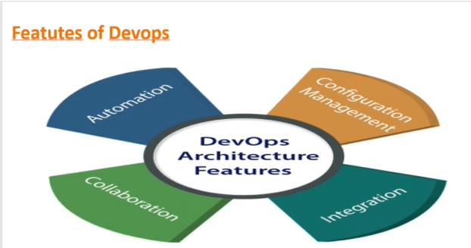

1.Automation

2.Config Management

3.Integration

4.Collaboration

Fig. DevOps Features

# 

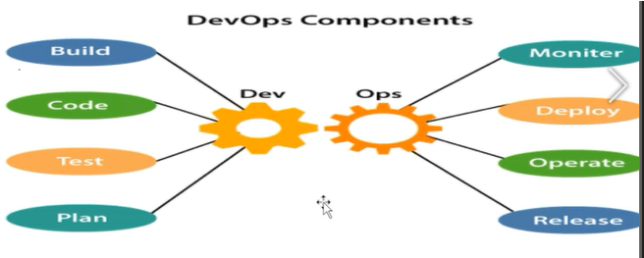 **Fig. DevOps Architecture**

8 components

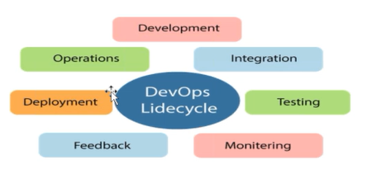F**ig. DevOps Components**

7 stages

Fig. DevOps Lifecycle

**Fig. DevOps Lifecycle**

# Different Tools Used in DevOps

1.Cont. Plan - GIT

2.cont. Integration - Jenkins

3.Testing - Selenium

4. Cont. monitoring-Datalog, Nagios

5. Feedback -

6. Deployments - Chef, Ansible.

7 Operations - Jenkins